**CSE 2016 - Software Engineering Laboratory**

**ONLINE FASHOIN STORE**

**Prepared by:**

**ROICE VITHAYATHIL (20BCB7064) LEAD**

**K. LAKSHMI NARASIMHA REDDY (20BCB7069)**

**N. VISHNU PRABHAS REDDY (20BCB7103)**

**TEAM-10**

**LAB 12**

**06-10-2021**

**6.Screenshots of website:**

**Screenshot of login page:**

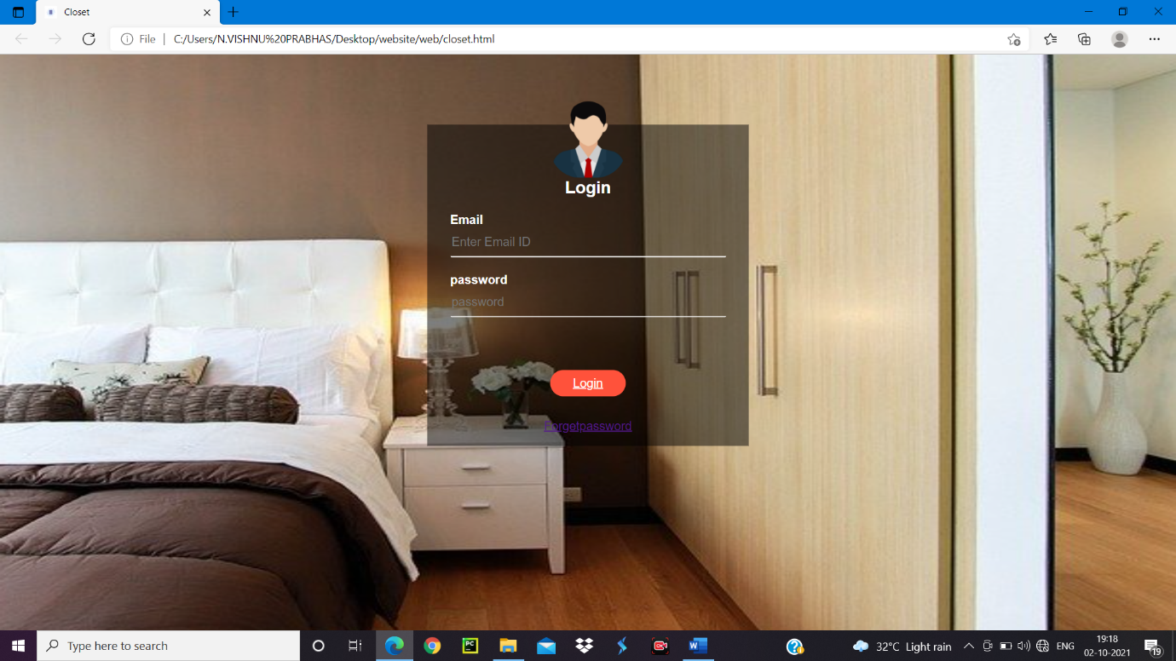

**Screenshot of home page of website:**

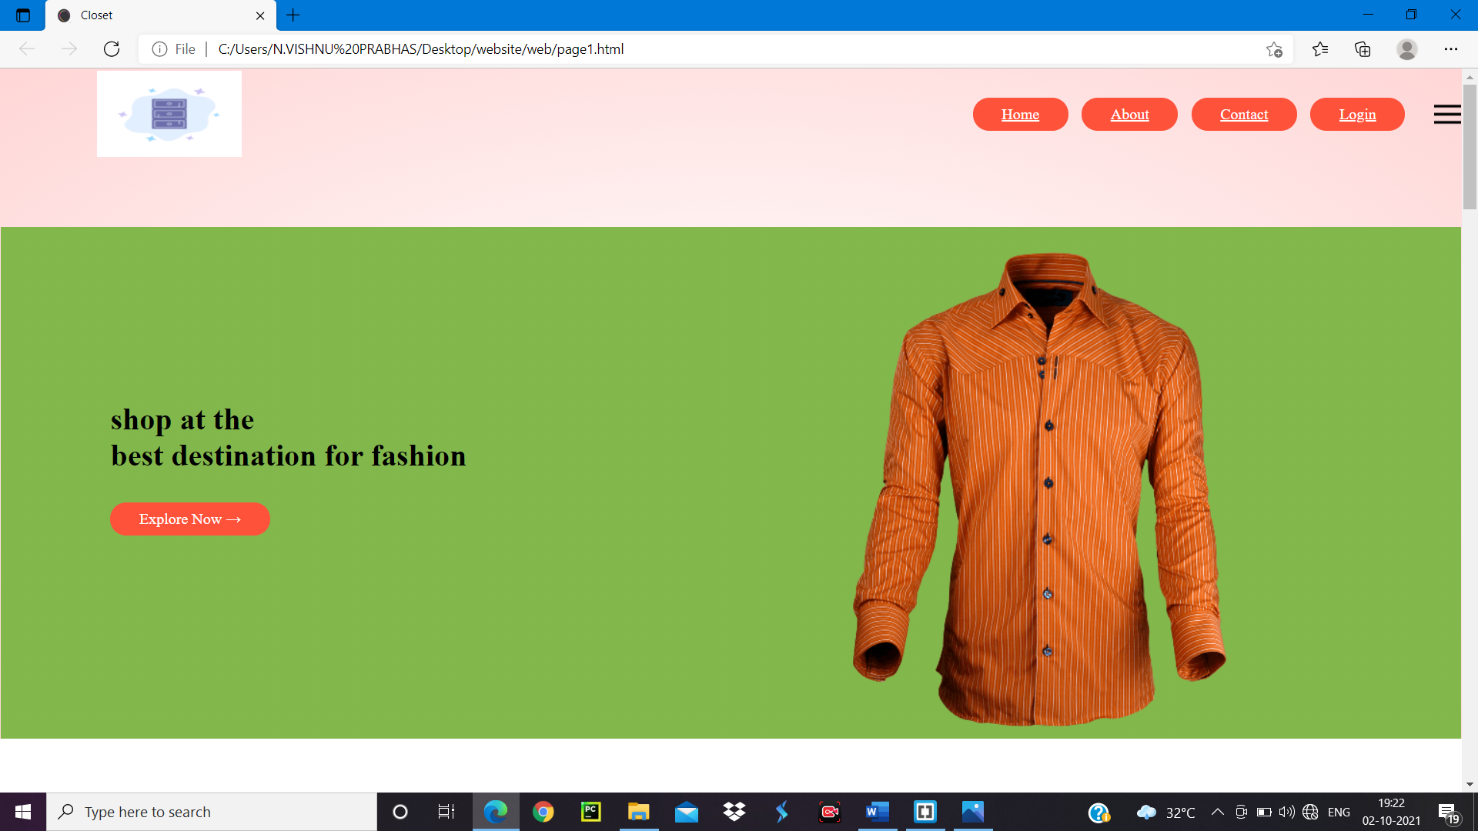

**Few screenshots of product display page:**

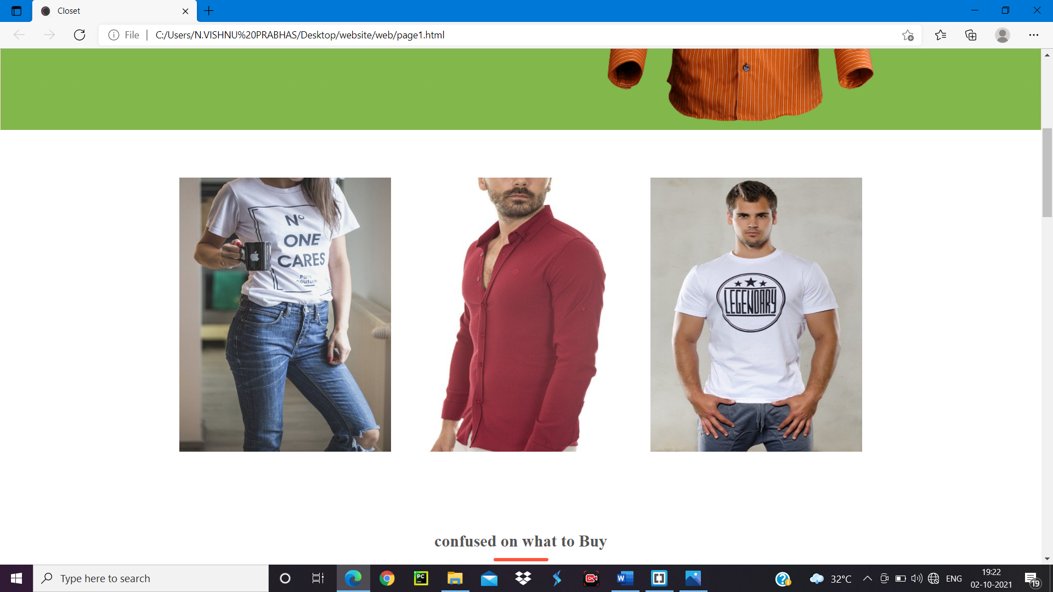

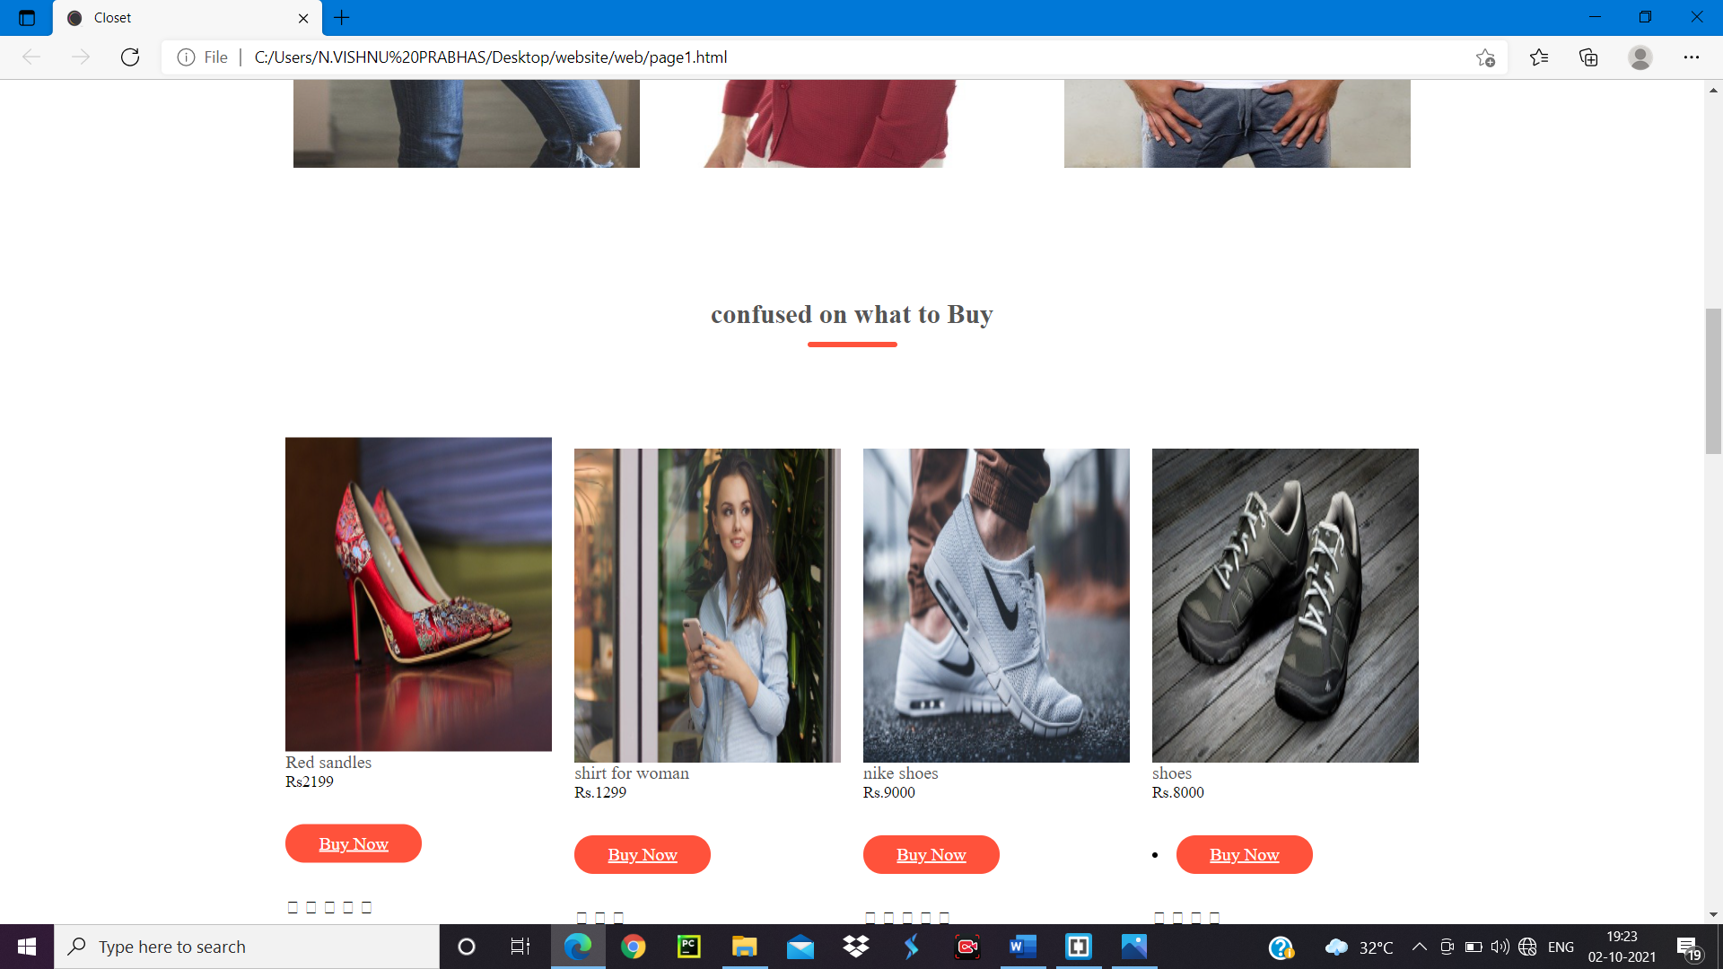

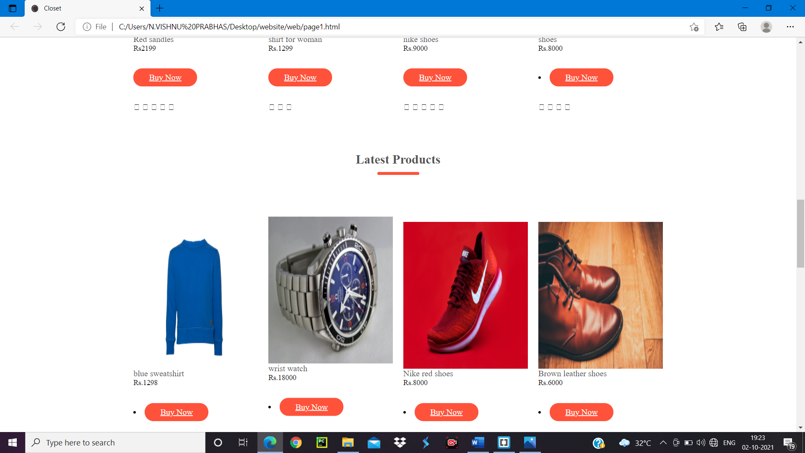

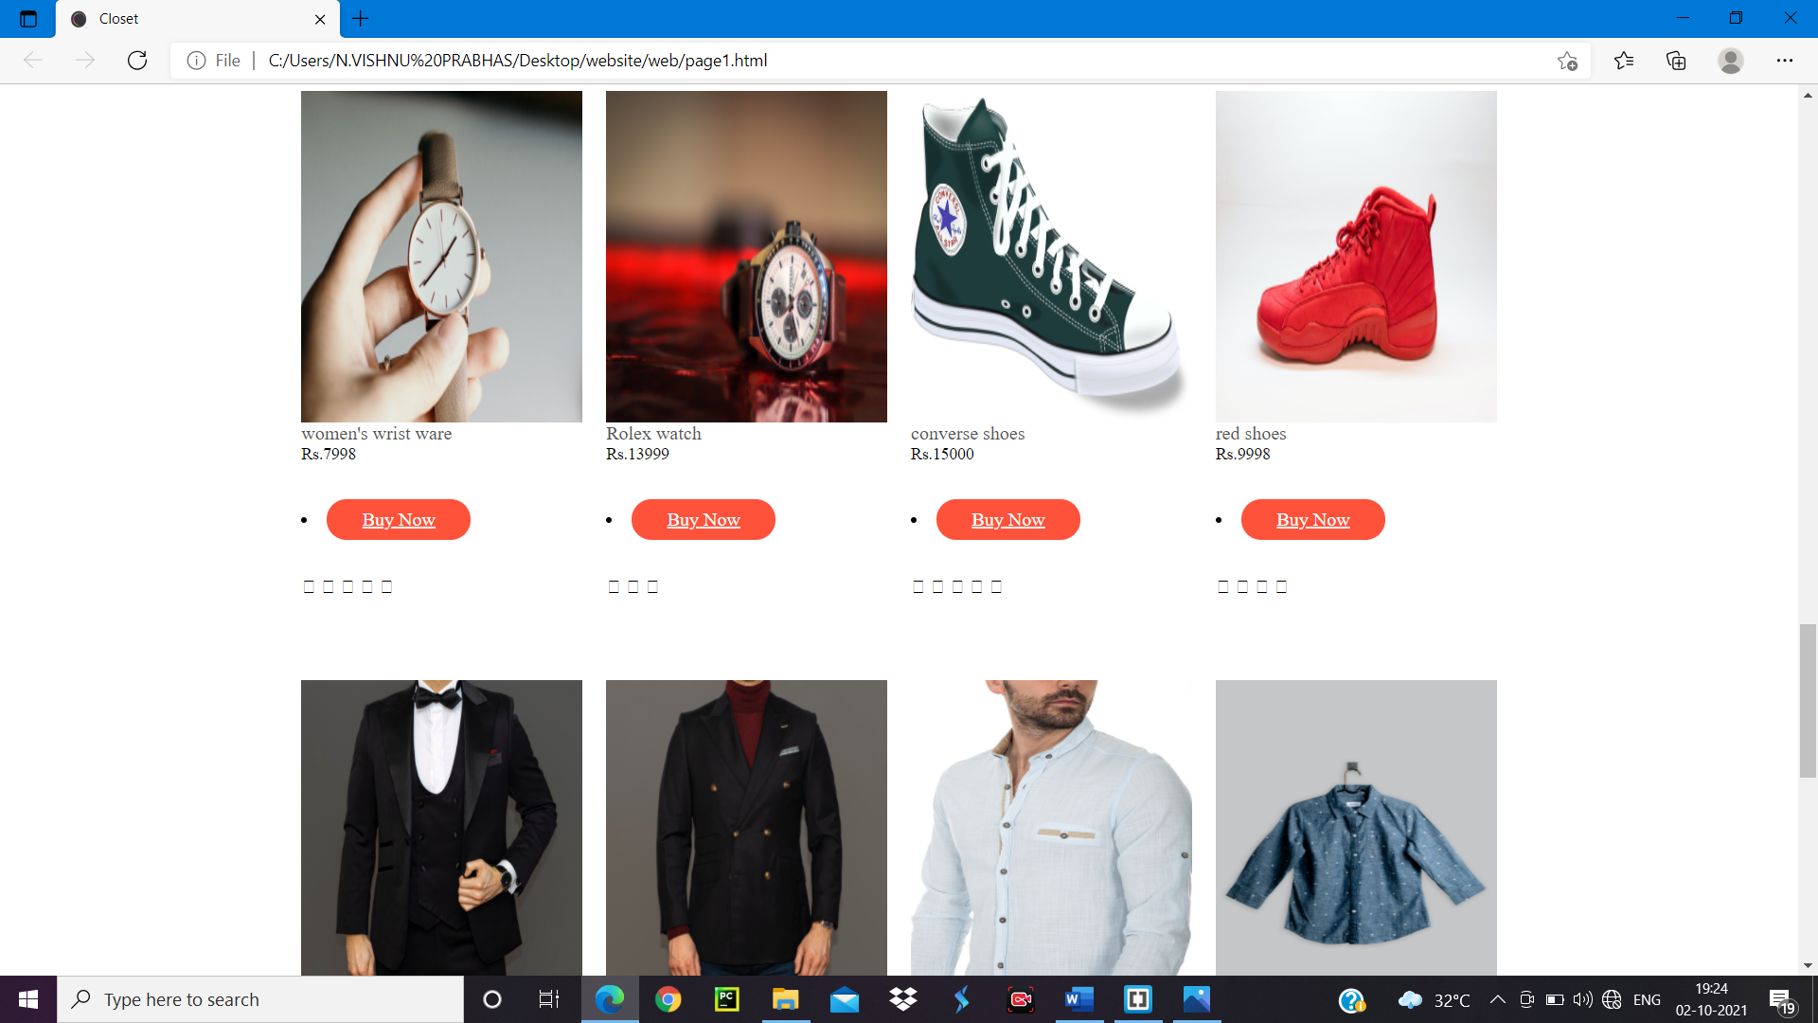

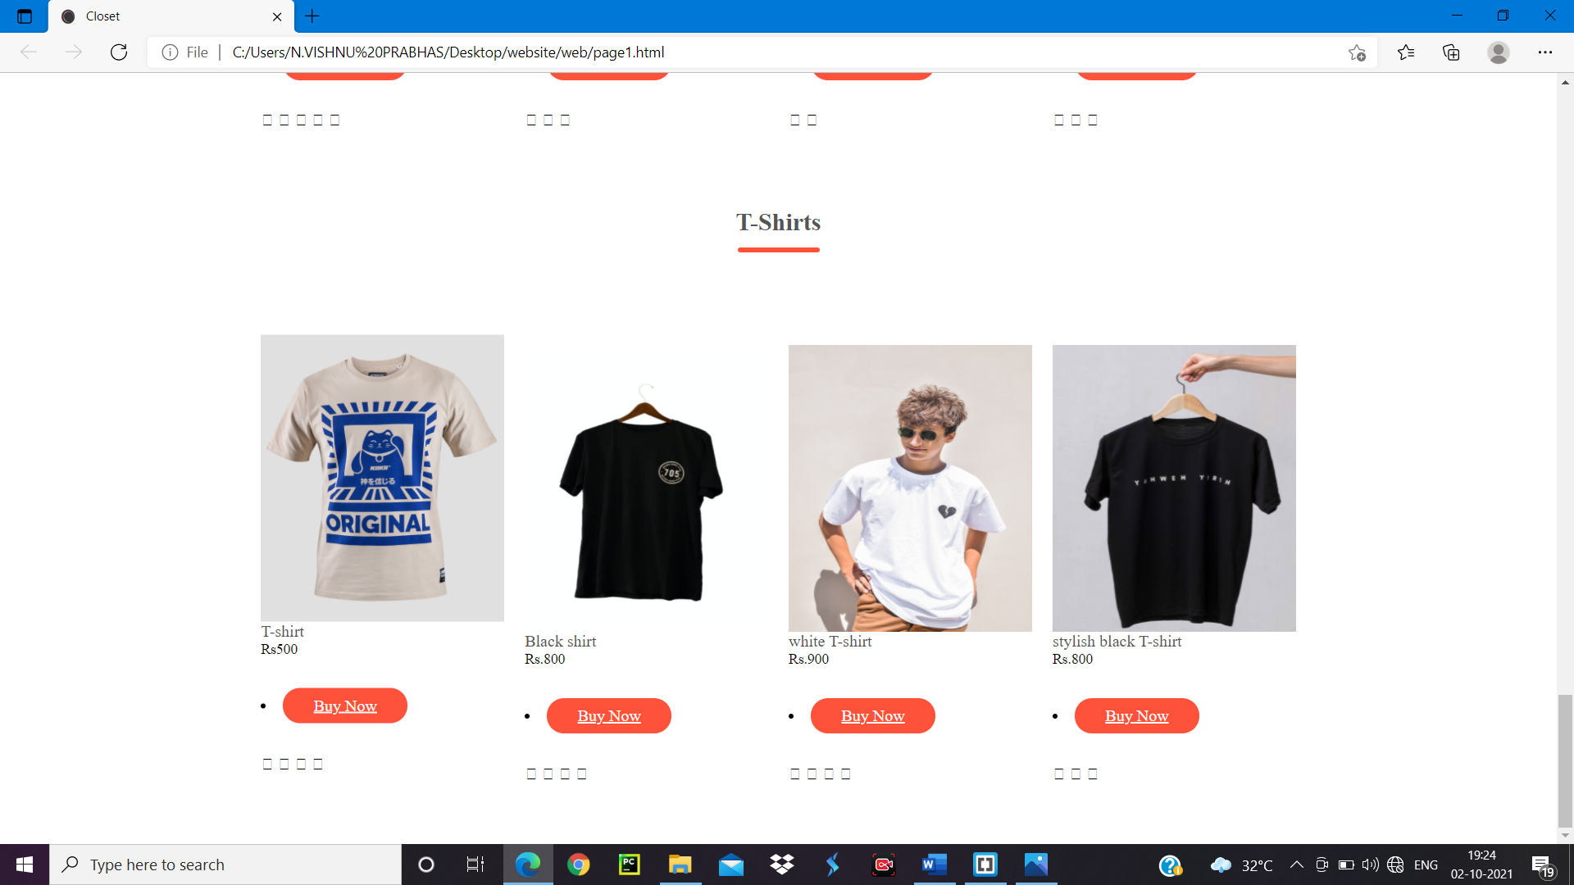

**Screenshot of address updating page:**

